Practice Questions week 7

Write a NumPy program to get the numpy version and show numpy build configuration.

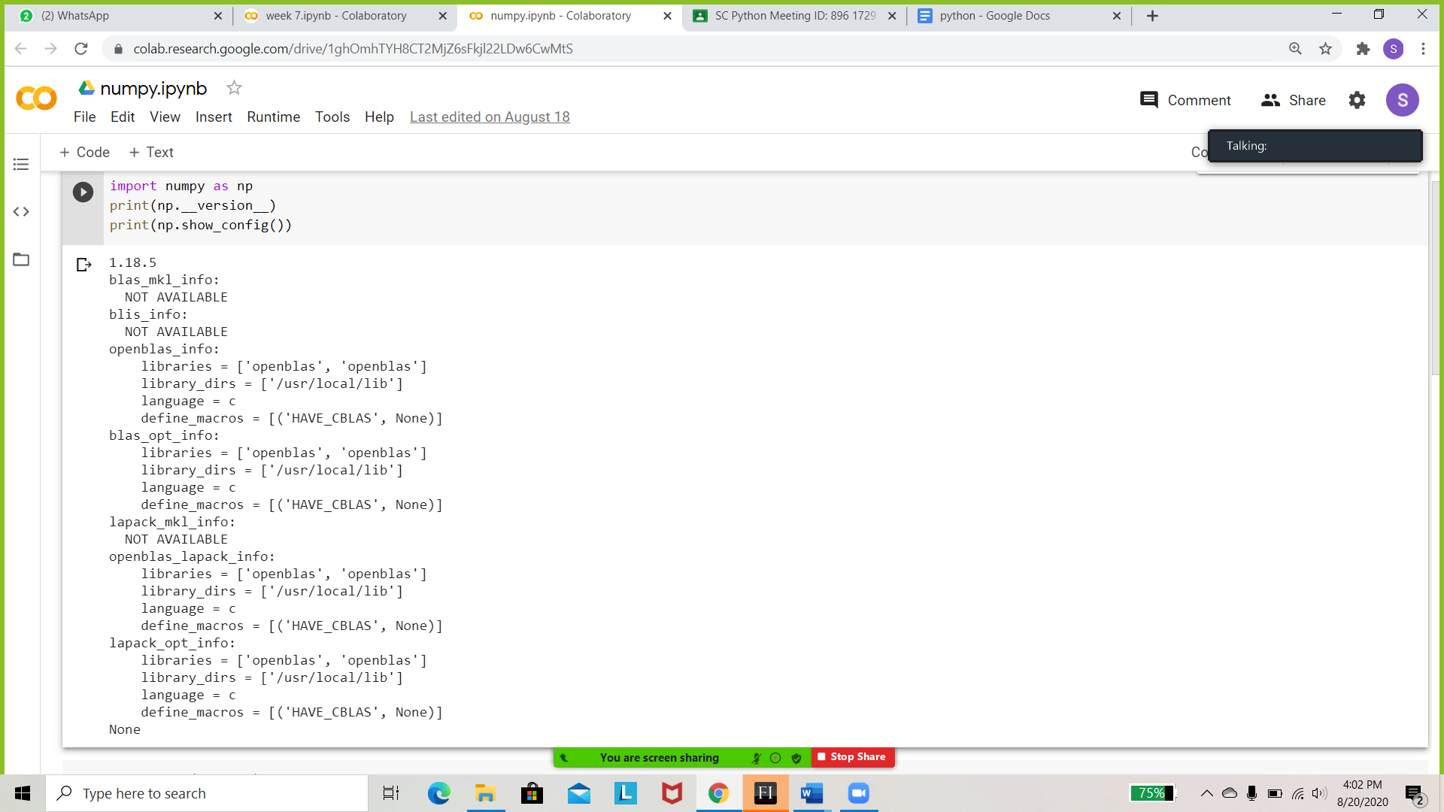

Write a NumPy program to test whether none of the elements of a given array is zero.

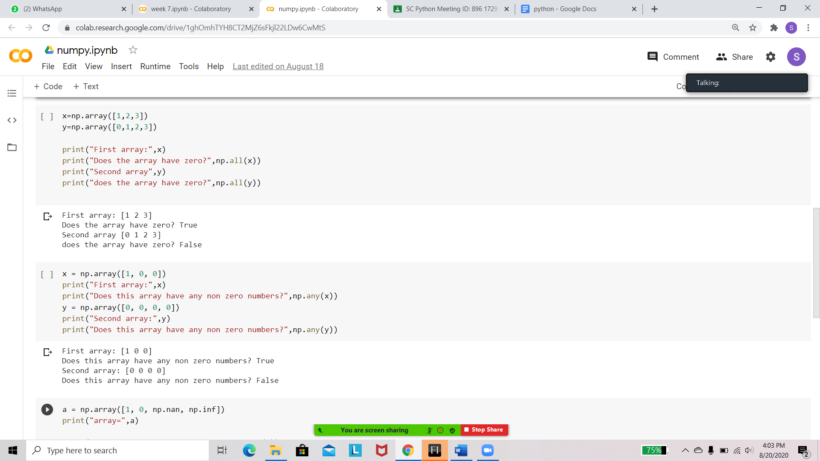

Write a NumPy program to test whether any of the elements of a given array is non-zero.



Write a NumPy program to test a given array element-wise for finiteness (not infinity or not a Number).

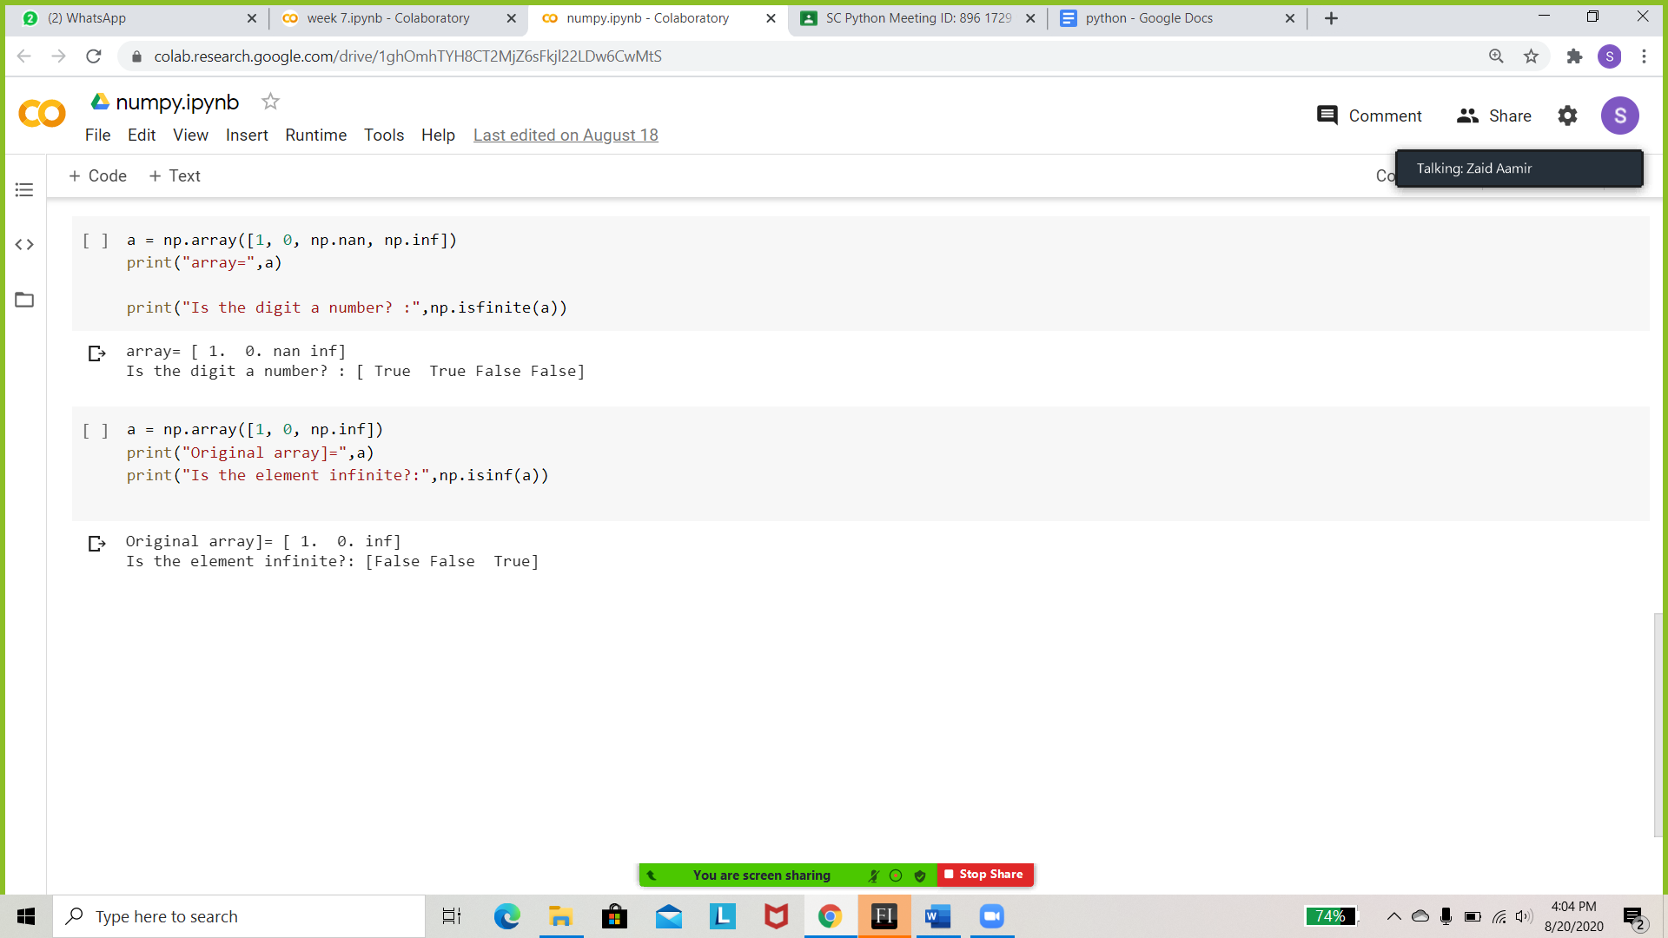

Write a NumPy program to test element-wise for positive or negative infinity.

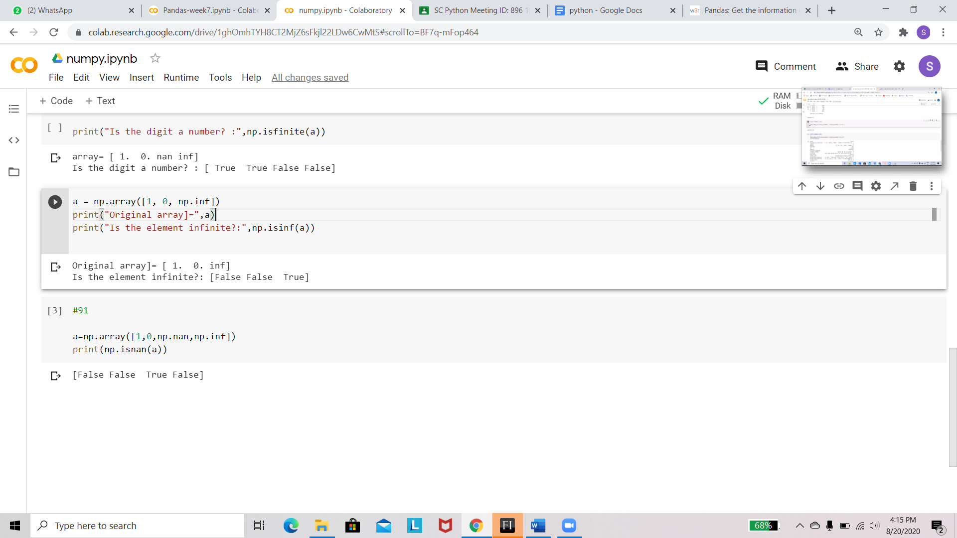

Write a NumPy program to test element-wise for NaN of a given array.



Write a Python Pandas program to get the columns of the DataFrame .

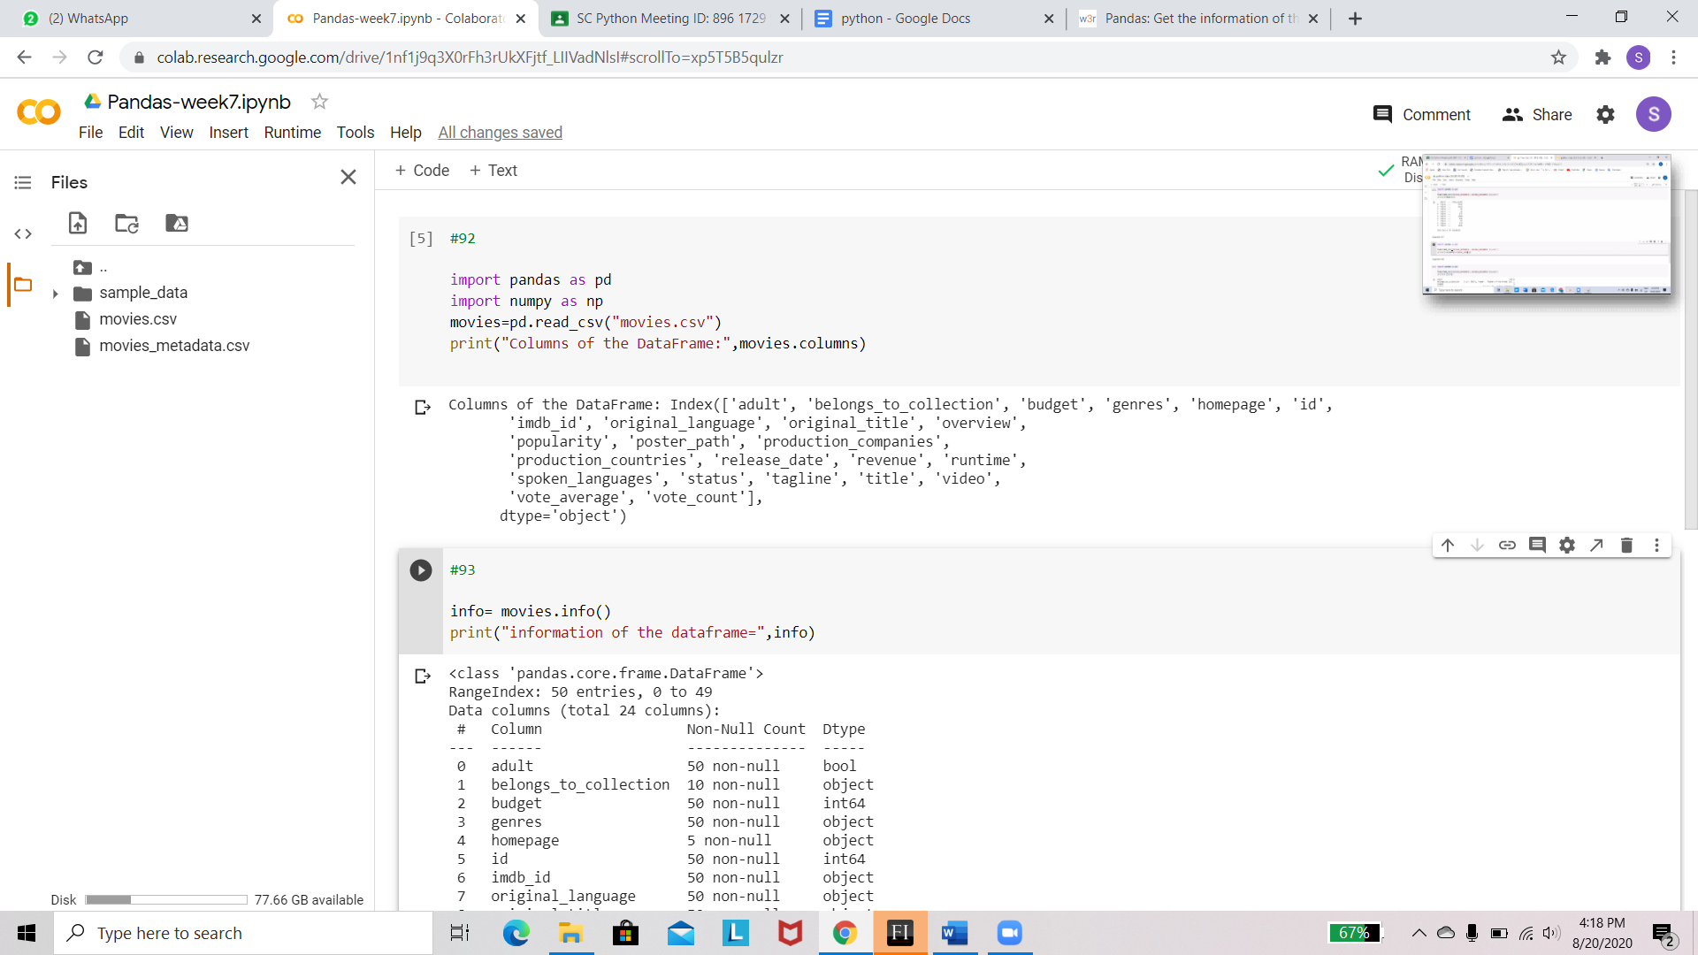

Write a Pandas program to get the information of the DataFrame (movies_metadata.csv file)including data types and memory usage.

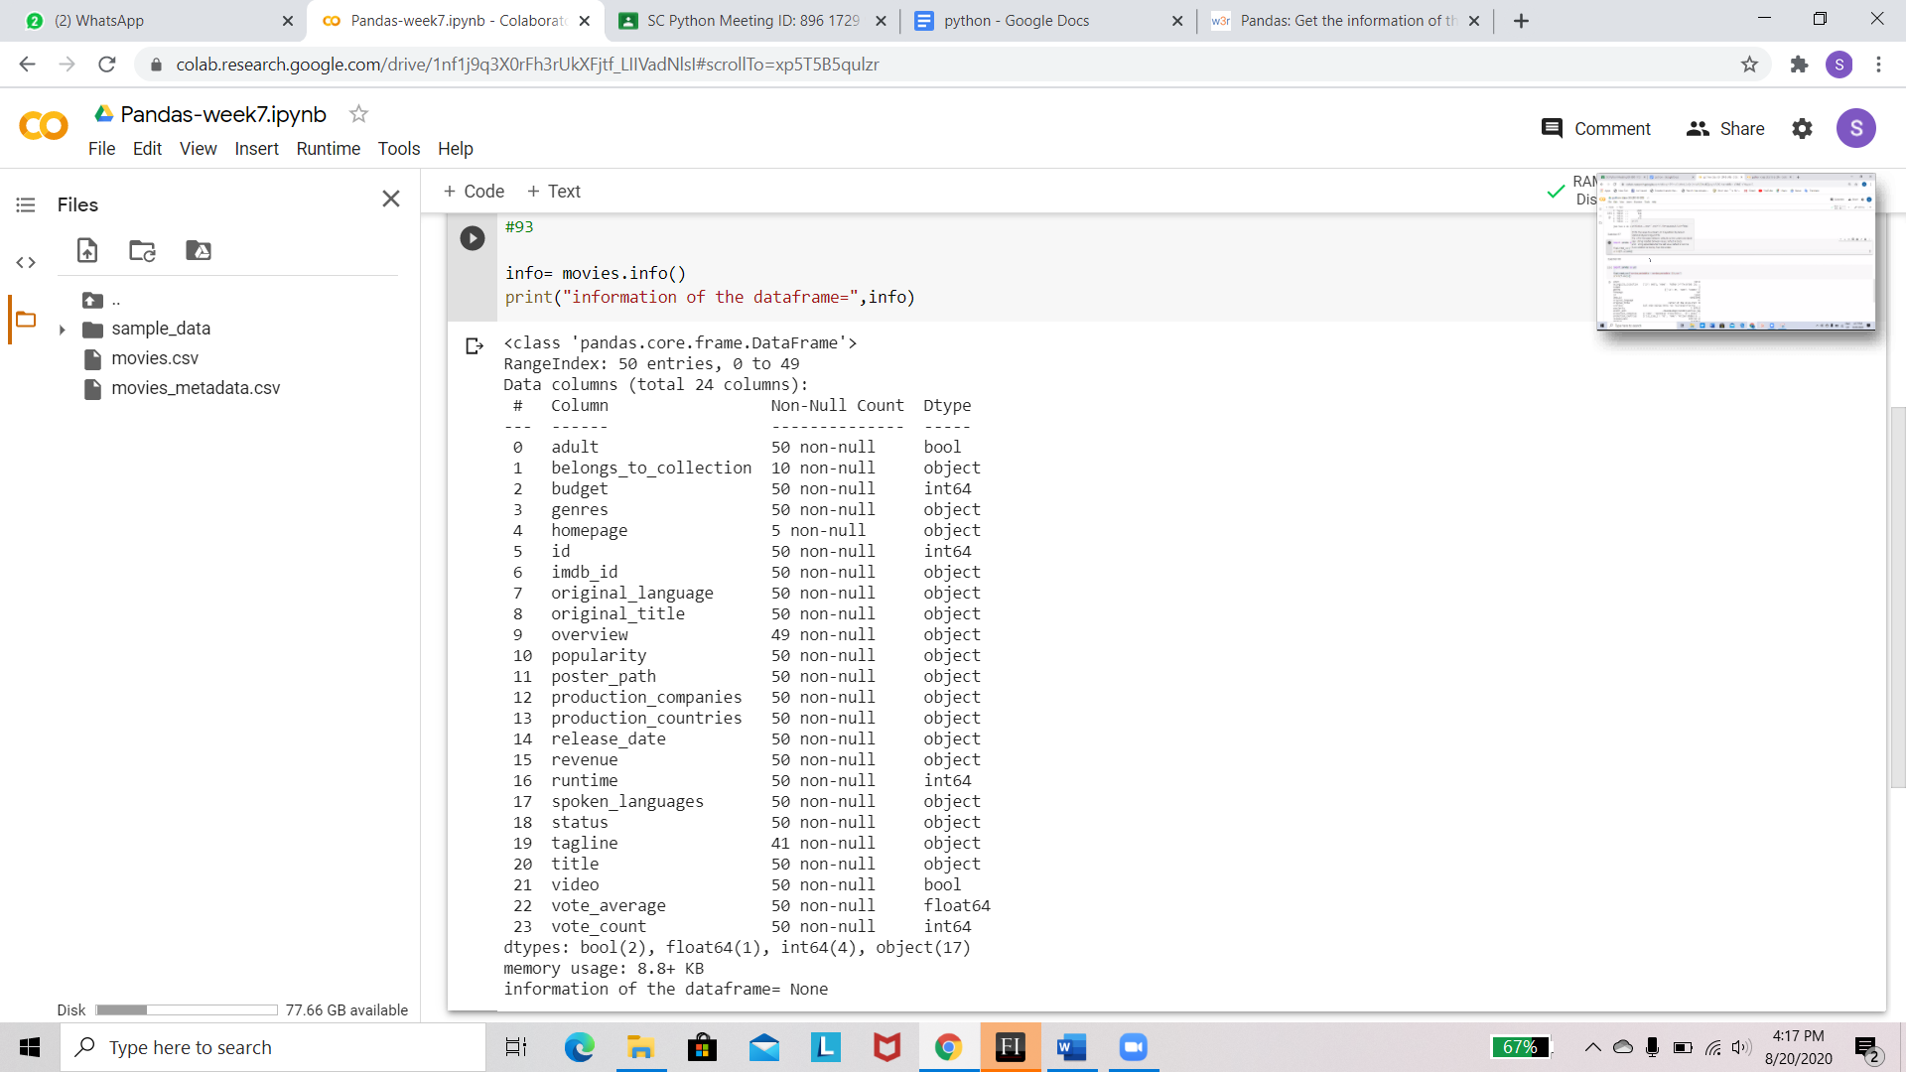

Write a Pandas program to get the details of the third movie of the DataFrame

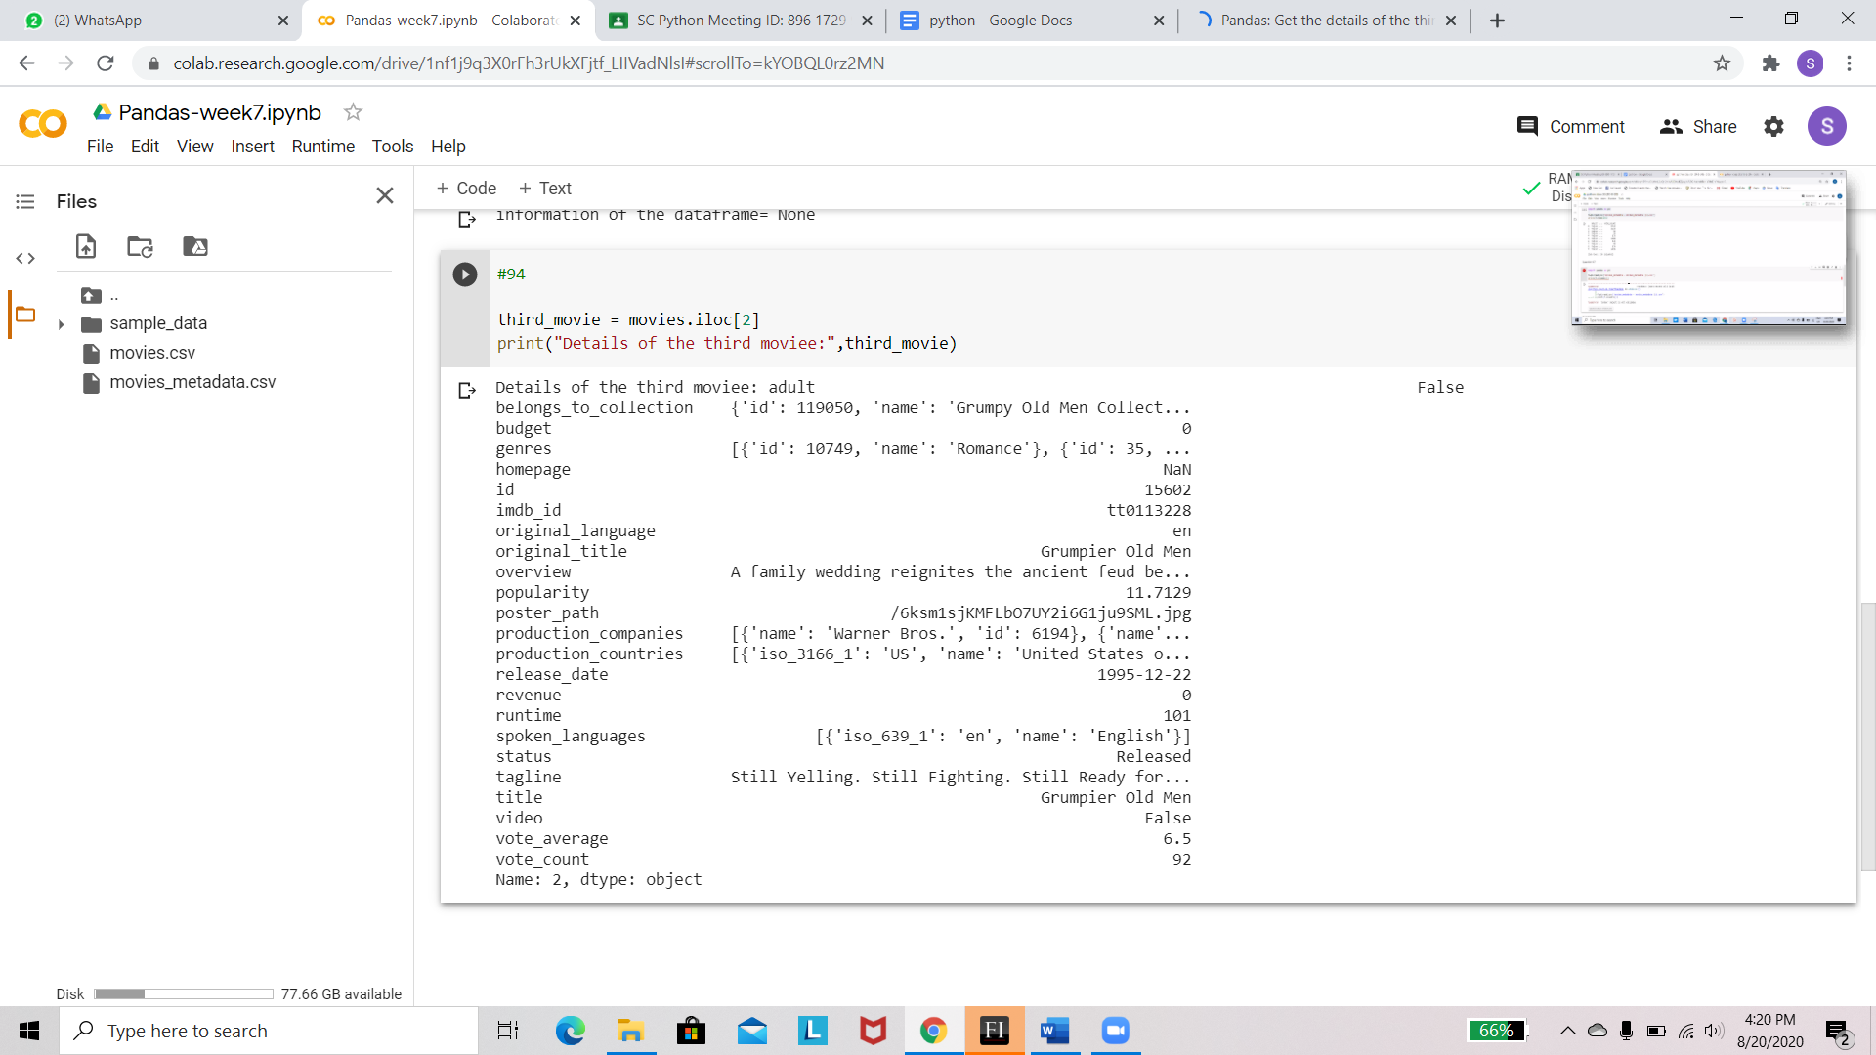

Write a Pandas program to count the number of rows and columns of the DataFrame

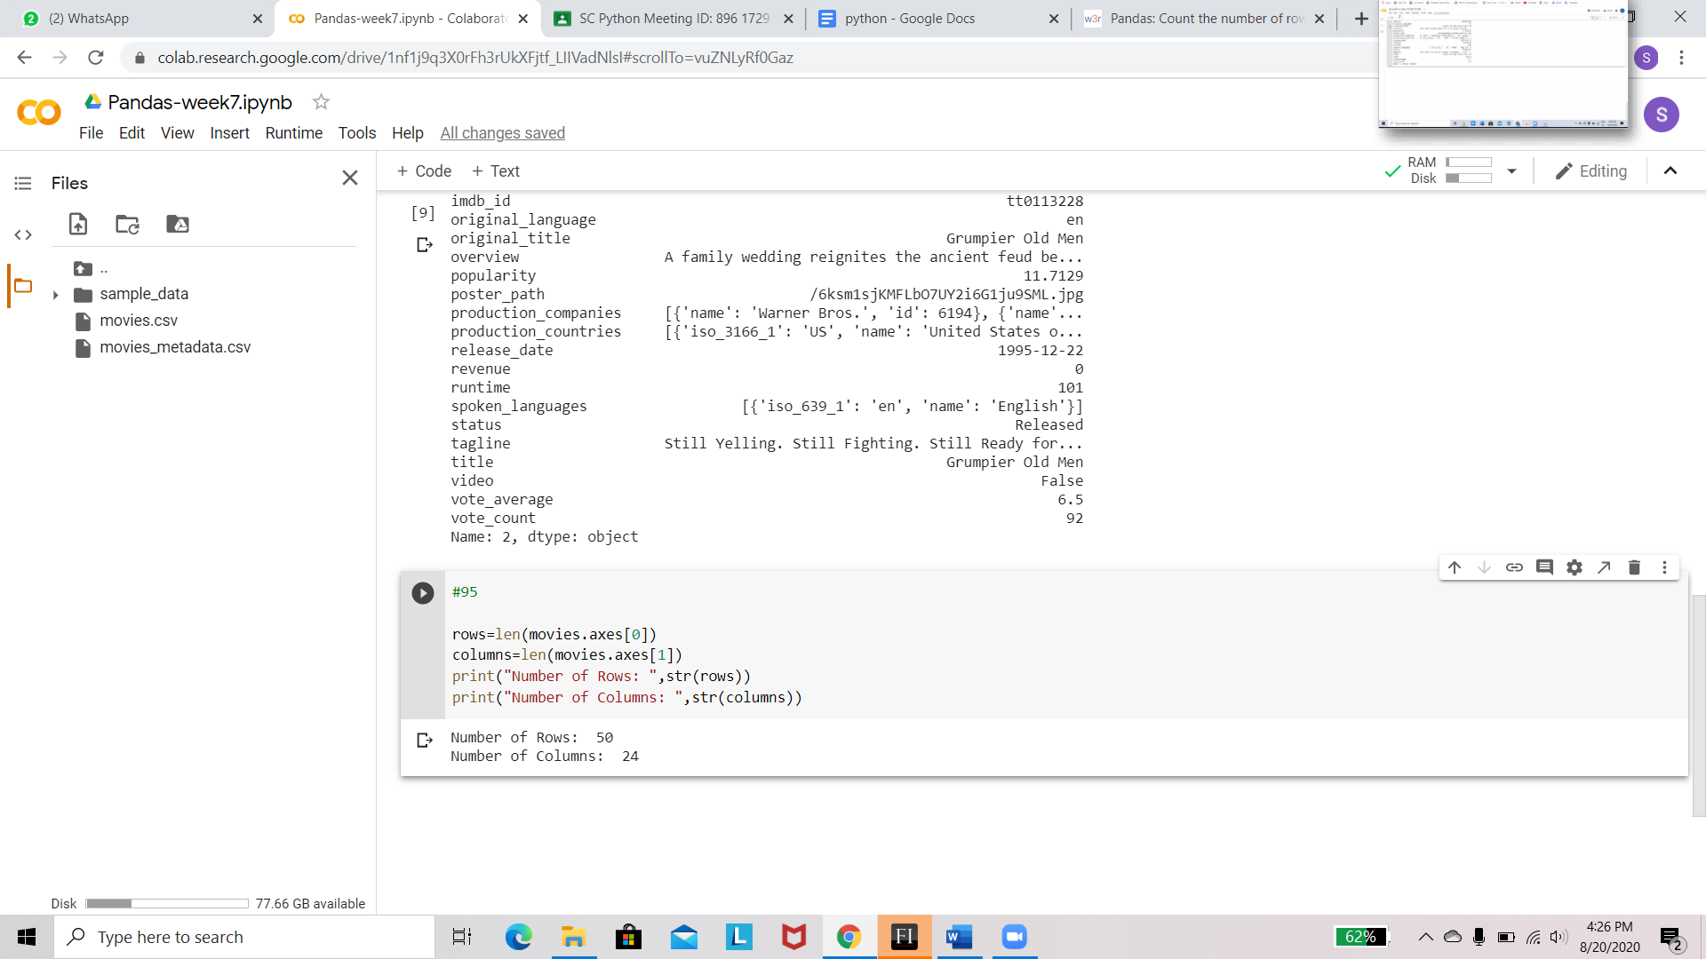

Write a Pandas program to display the first 10 rows of the DataFrame.

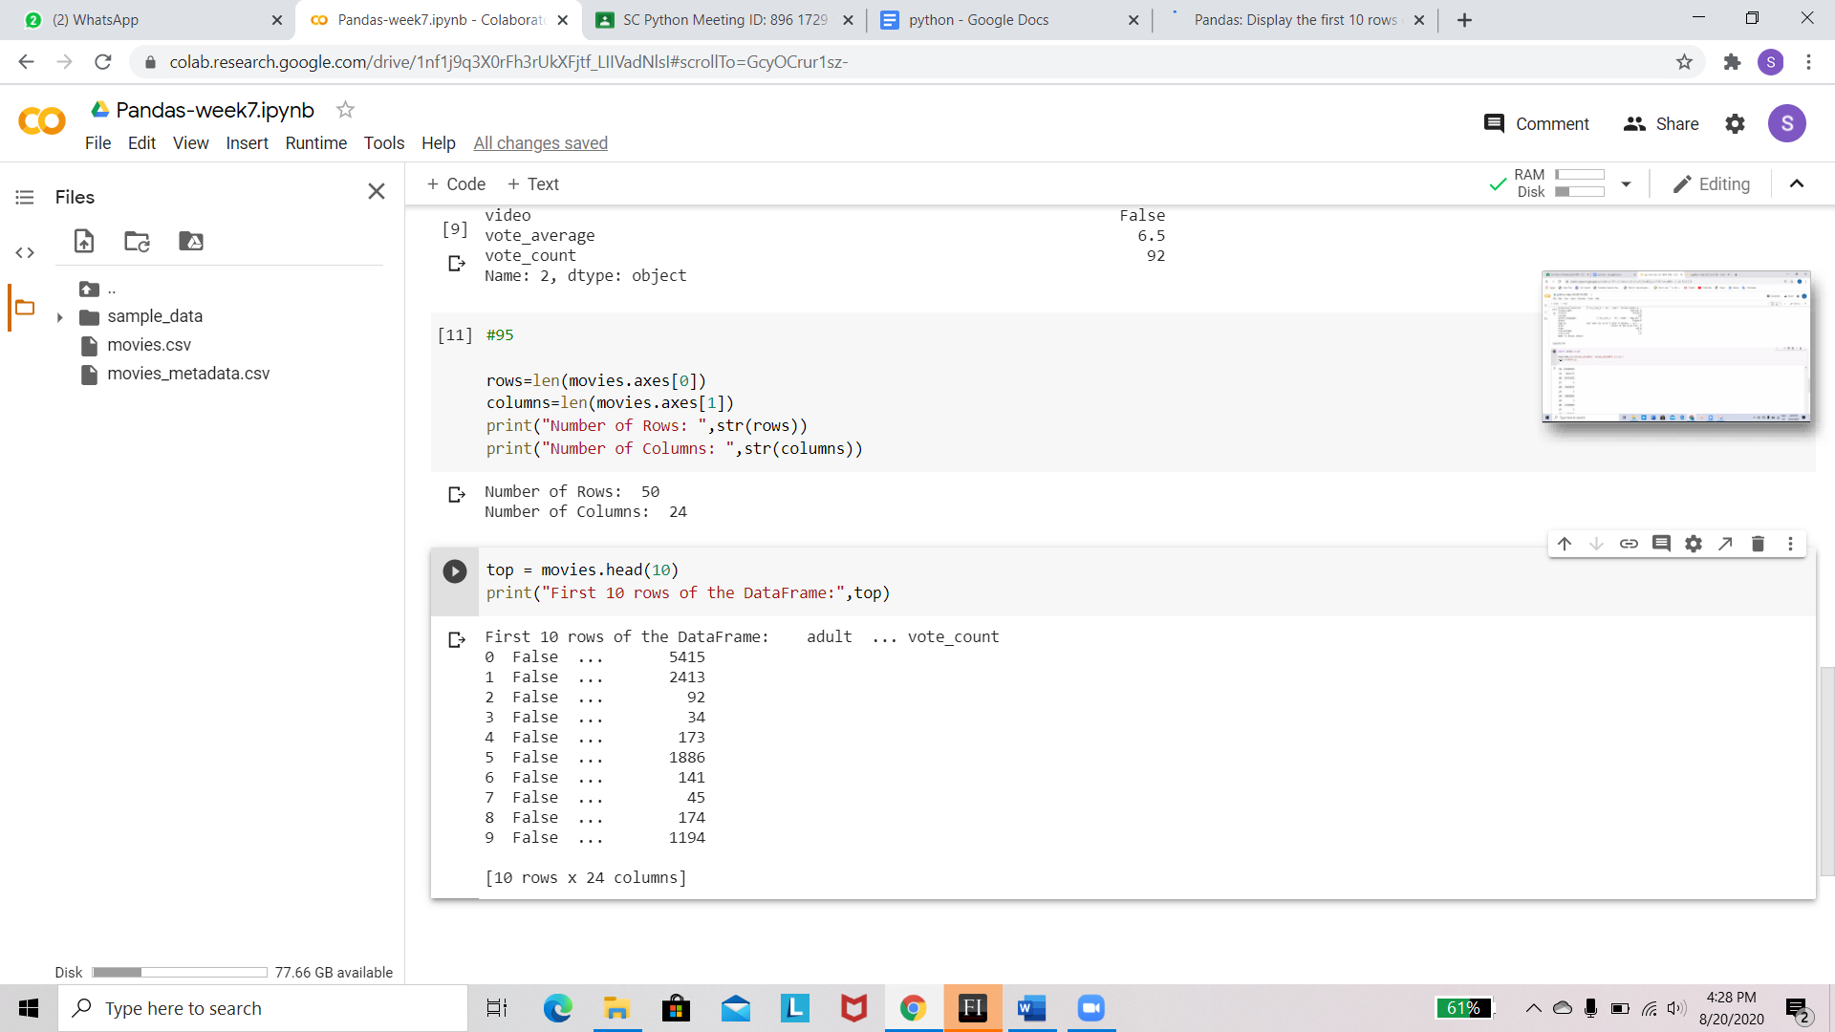

Write a Pandas program to sort the DataFrame based on release_date.

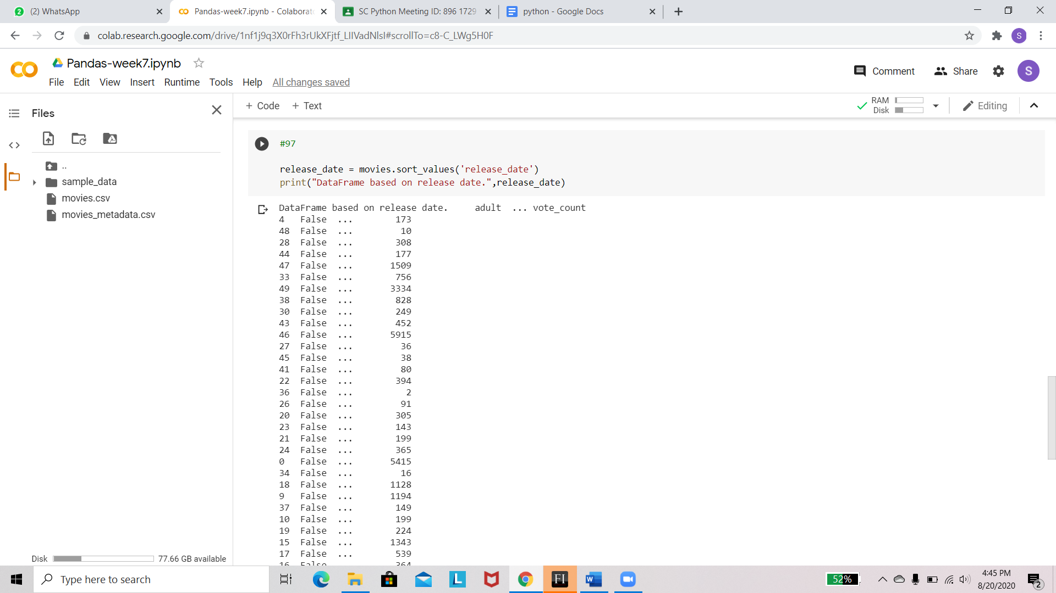

Write a Pandas program to get the details of the fifth movie of the DataFrame.

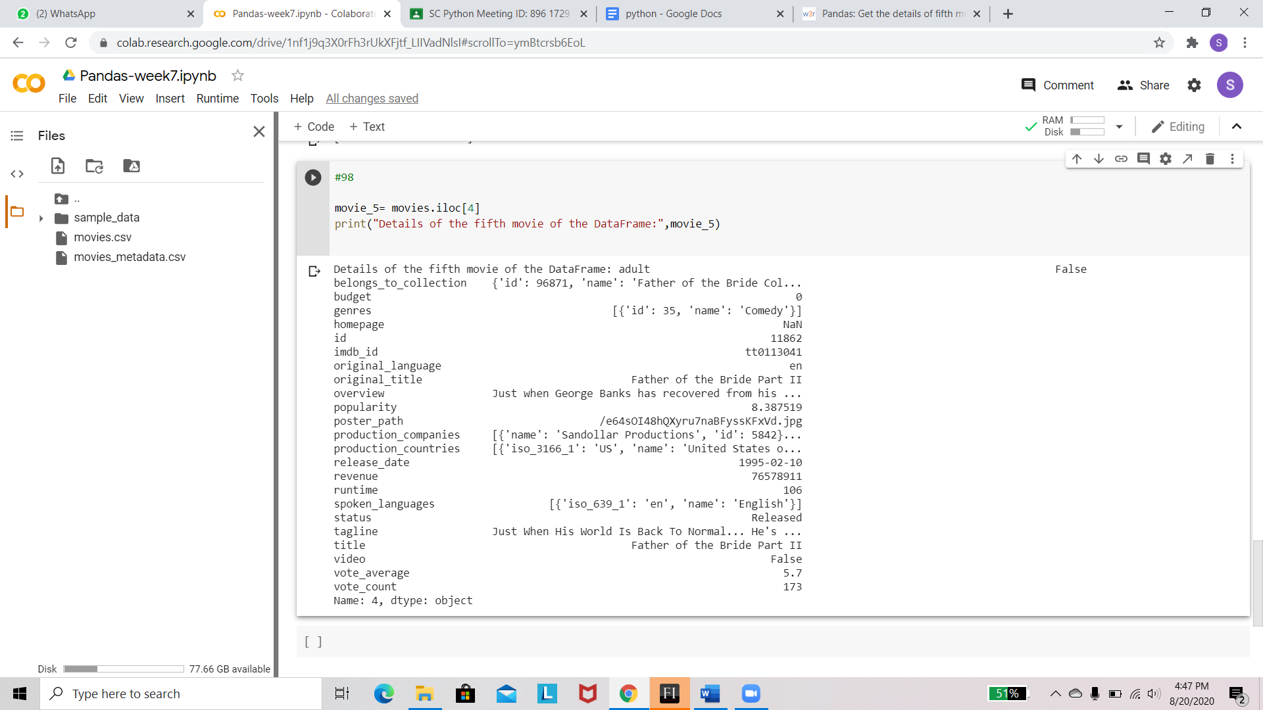

Write a Pandas program to get those movies whose runtime is more than 100mins

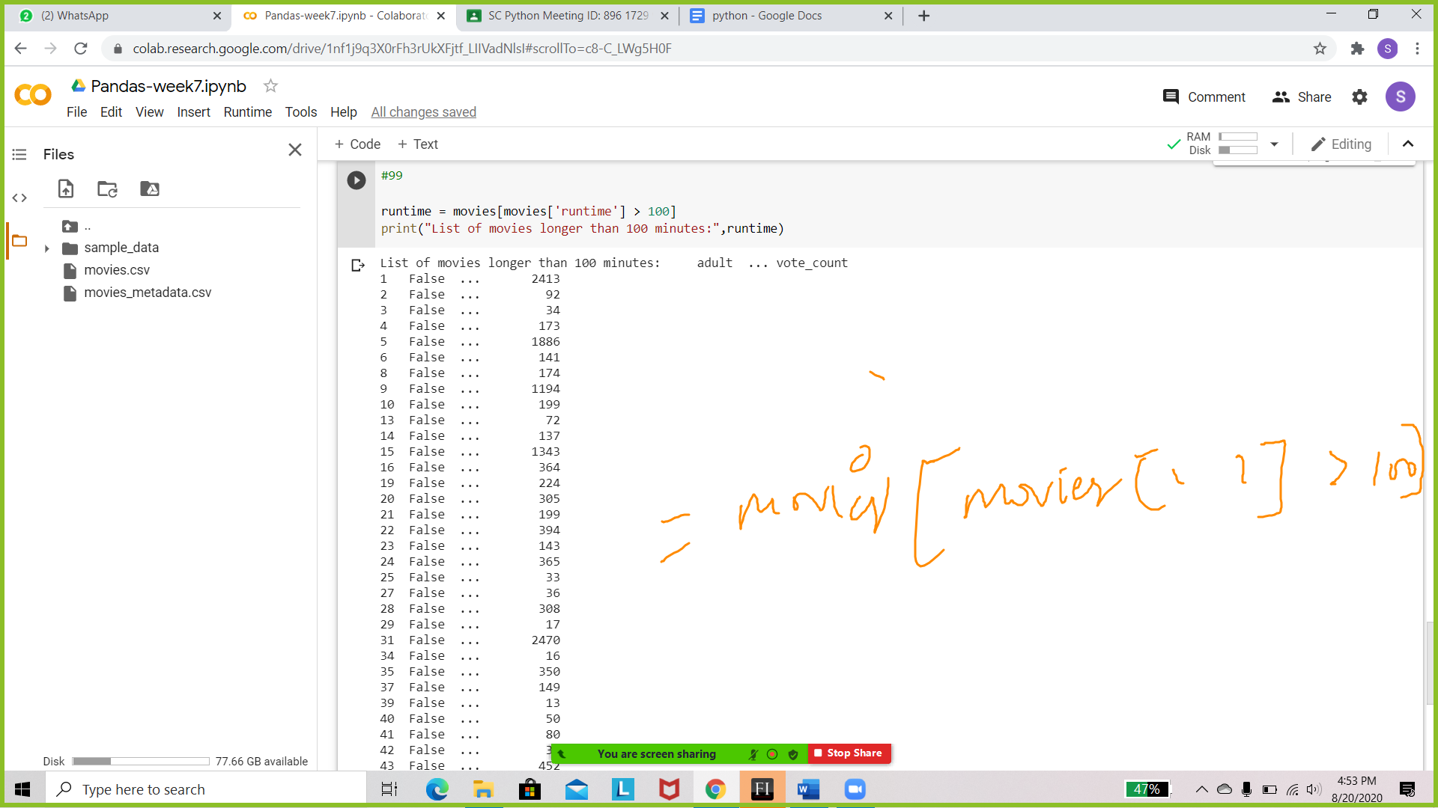

Auto dataset - drop missing values in file.

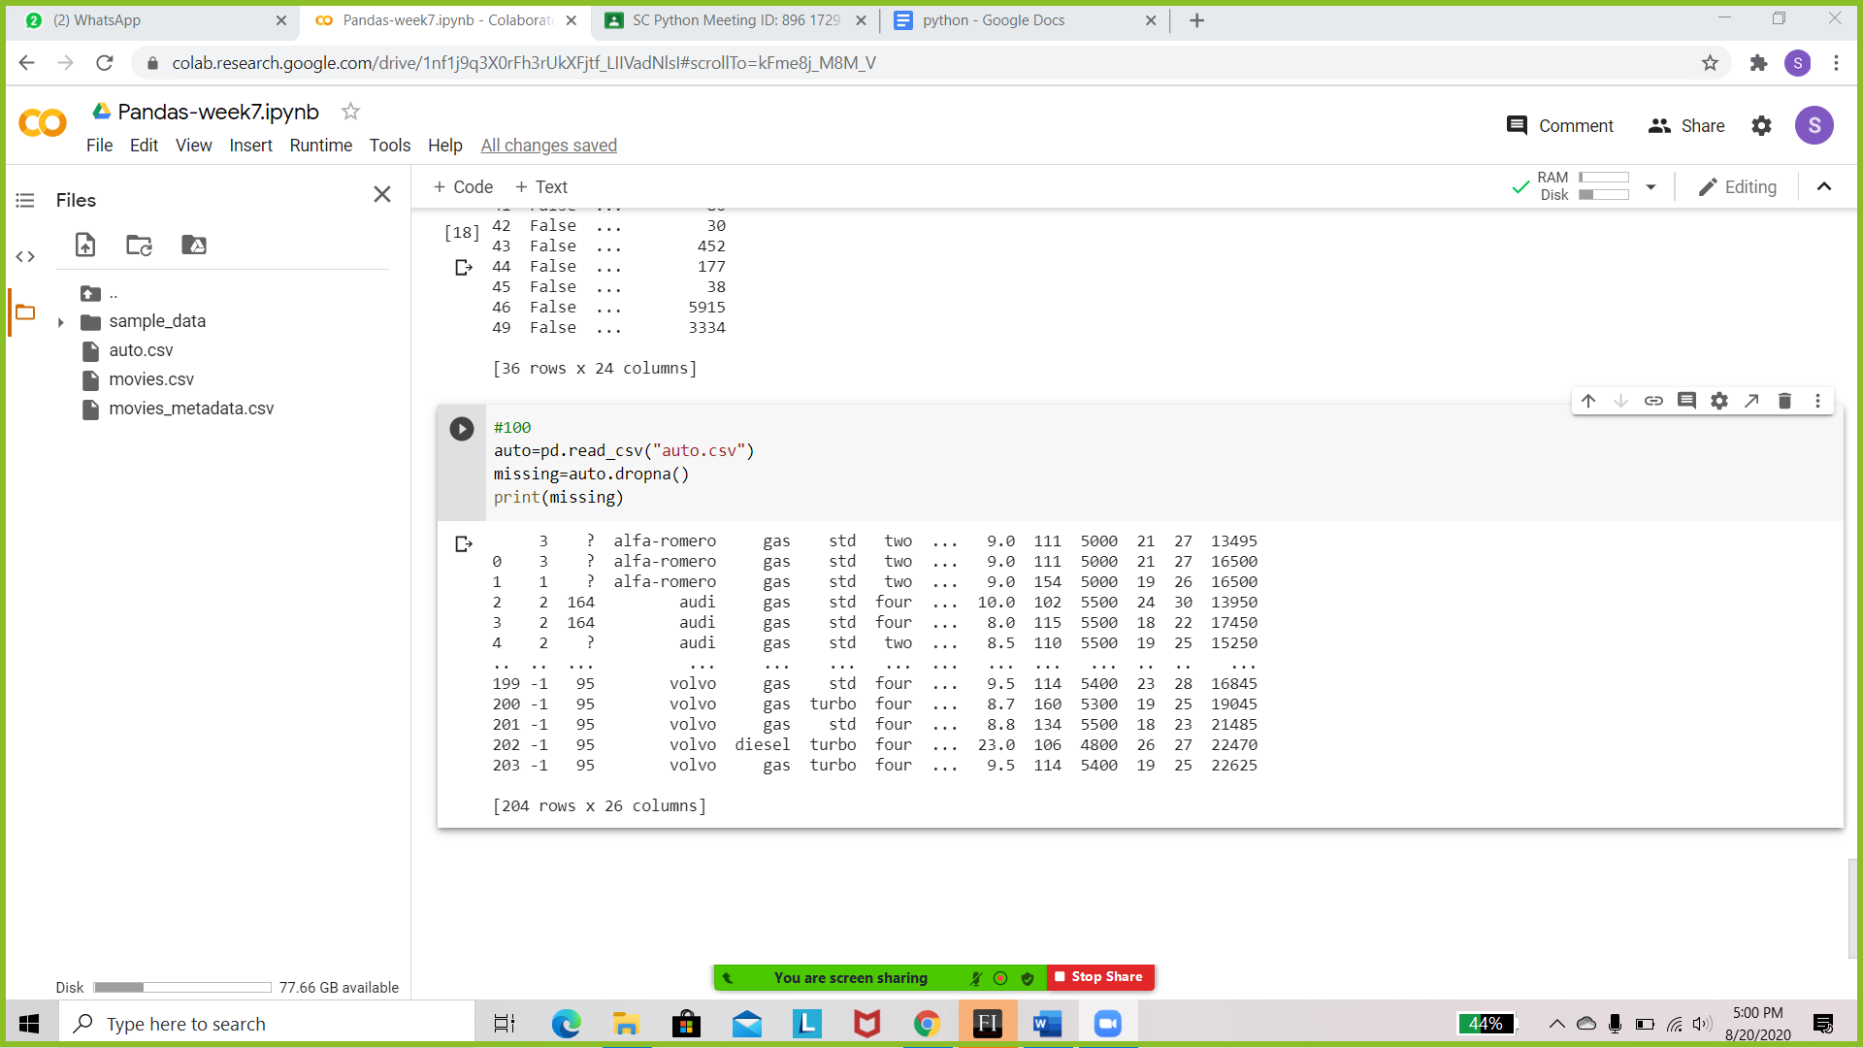

Auto dataset - drop missing values along the column "gas".